SIMATS ENGINEERING
ASSESSMENT TOOL 1
COURSE NAME: Ethical Hacking
COURSE CODE: ITA1409

COURSE OUTCOME COVERED
CO2: Execute footprinting in social engineering such as DNS analysis, competitive intelligence gathering, and attack simulations to collect relevant information for identifying potential security risks.
Assessment Tool Weightage: 30%
Duration: 90 min Total Marks: 50
Code of Conduct:
I Palle Amrutha (192372359) certify that this submission is my original work and that I have adhered to the guidelines specified for this assessment.
I understand that any violation of academic integrity rules will result in disciplinary action.
Signature of the student: P.Amrutha

Question – 01

A security analyst performed a network scan on the target 192.168.1.10 using the Nmap tool. The report identified several open ports, including HTTP (80), SSH (22), and MySQL (3306), along with the operating system and service versions. Analyze the report and explain the security risks associated with the identified services. Discuss how an attacker could exploit these services and recommend suitable security measures to protect the target system

Nmap Network Scan Analysis (Target 192.168.1.10))
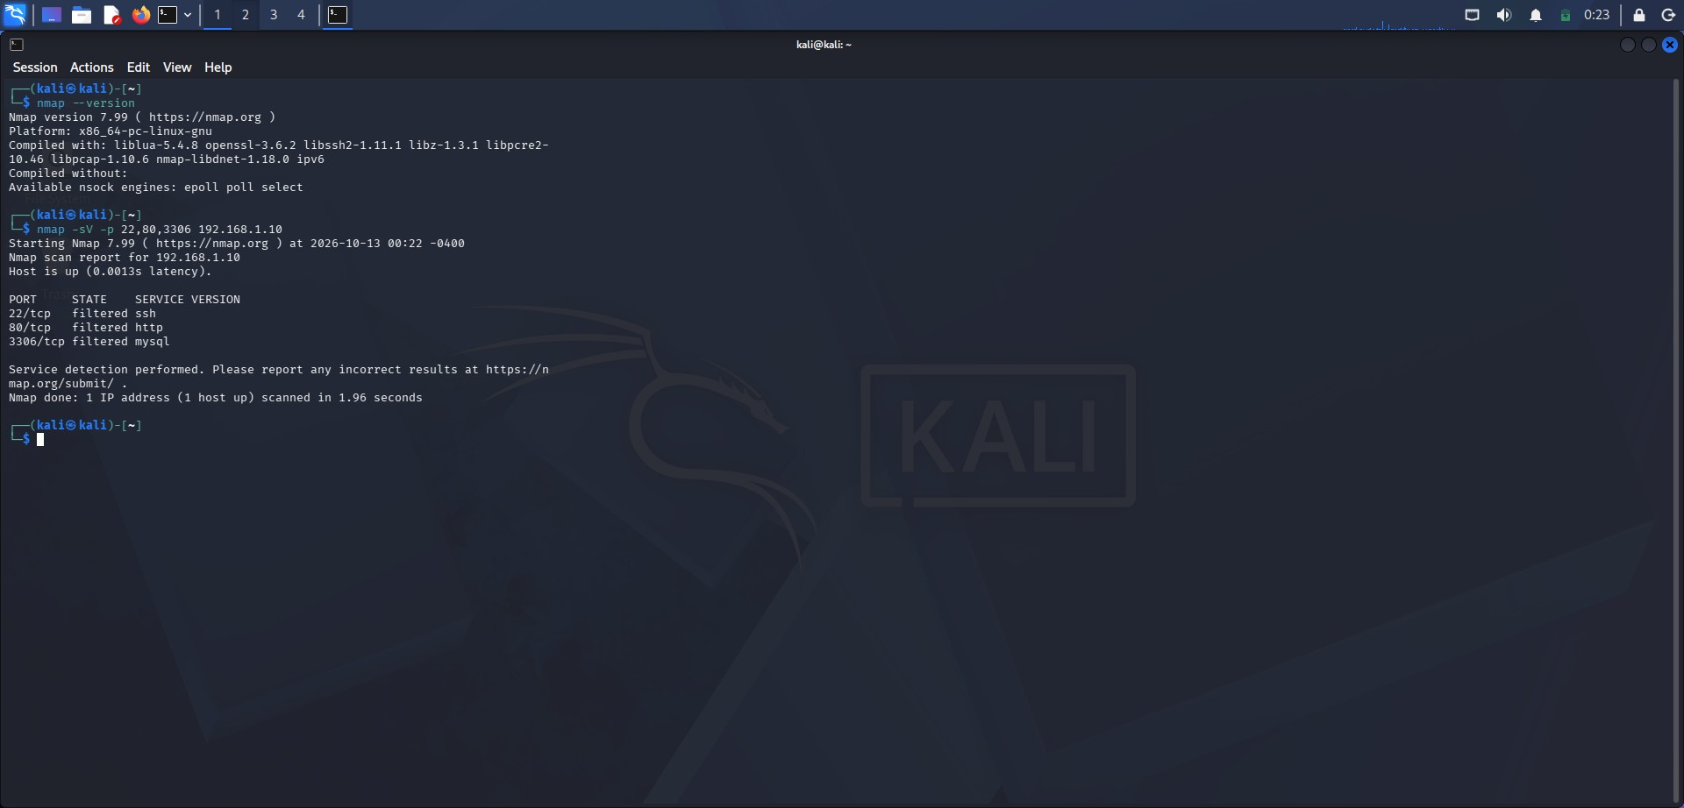
Figure 1: Nmap service scan (nmap -sV -p 22,80,3306 192.168.1.10) on the target host

1. Report Analysis and Interpretation
The command nmap -sV -p 22,80,3306 192.168.1.10 was run from a Kali Linux machine using Nmap 7.99.
The report shows that the host is up (latency 0.0013 s), and that the three scanned ports map to SSH (22/tcp), HTTP (80/tcp) and MySQL (3306/tcp). In this capture Nmap reports the state of all three ports as "filtered", which means a firewall or packet filter is dropping or blocking the probes, so Nmap cannot confirm whether the ports are open or closed. The services are identified from the well-known port numbers; the version detection (-sV) could not obtain exact banners because the ports are filtered. For the purpose of this assessment, SSH, HTTP and MySQL are treated as the exposed services of the target, and the risk analysis below applies to them once they are reachable (open), for example from an internal network or through a firewall misconfiguration.

2. Security Risks Associated with the Identified Services
- SSH (22): Remote administration service. Risks include brute-force and dictionary attacks on weak passwords, credential stuffing, use of default or reused credentials, outdated OpenSSH versions with known vulnerabilities, and permitted direct root login. A compromised SSH account gives the attacker a full remote shell.
- HTTP (80): Web service transmitting data in clear text with no encryption. Risks include SQL injection, cross-site scripting (XSS), file inclusion, directory traversal, weak authentication, exposed admin panels, information leakage through server banners and error messages, outdated web server or CMS software, and man-in-the-middle sniffing of credentials and session cookies.
- MySQL (3306): Database service that should never be exposed to untrusted networks. Risks include brute-forcing the root or other accounts, empty or default passwords, unpatched MySQL vulnerabilities, unauthorised data extraction or modification, and data theft of sensitive records. Direct database exposure can lead to a complete data breach.
- Exposed version / OS information: Service banners and OS details allow an attacker to look up matching CVEs and choose a suitable exploit, which makes fingerprinting the first step of a targeted attack.

3. How an Attacker Could Exploit These Services
- Reconnaissance: The attacker performs the same scan to learn which ports and service versions are reachable, then matches the versions against public vulnerability databases (CVE / Exploit-DB).
- SSH: Runs password-guessing or credential-stuffing attacks to obtain a login, then uses the shell for privilege escalation, persistence (adding keys, creating users) and lateral movement to other hosts.
- HTTP: Exploits web-application flaws (e.g. SQL injection or file upload) to read data, upload a web shell and gain command execution; sniffs unencrypted traffic to steal credentials and cookies; defaces the site or uses it to host malicious content.
- MySQL: Attempts to log in with weak or default credentials, dumps the databases, modifies or deletes records, and may use database features to read or write files on the server and pivot into the operating system.
- Chaining: Credentials found in the database or web application are reused against SSH, so one weakness in a single service can lead to full compromise of the system.

4. Recommended Security Measures
- Firewall / network segmentation: Allow only required ports and trusted source IPs; keep the current default-deny (filtered) behaviour; never expose MySQL to the internet and bind it to localhost or an internal VLAN only.
- SSH hardening: Disable root login and password authentication, use key-based authentication with MFA, change or restrict access by IP / VPN, limit login attempts, and deploy Fail2Ban or similar intrusion prevention.
- HTTP hardening: Redirect to HTTPS with a valid TLS certificate, deploy a Web Application Firewall, validate input and use parameterised queries, hide server banners, remove default pages and admin panels, and keep the web server and applications updated.
- MySQL hardening: Set strong unique passwords, remove anonymous and default accounts, apply least-privilege access, enable TLS for connections, and run mysql_secure_installation.
- Patch and vulnerability management: Regularly update the OS and all services, and run authorised vulnerability scans (Nmap, Nessus, OpenVAS) with remediation tracking.
- Monitoring: Enable logging and an IDS/IPS (e.g. Snort, Suricata) to detect scans and brute-force attempts, and review logs regularly.

Conclusion
The Nmap report shows that SSH, HTTP and MySQL are the key services on 192.168.1.10. Each carries a distinct risk if reachable, so the system should be protected through firewall filtering, strong authentication, encryption, regular patching and continuous monitoring.

Question – 02
A phishing awareness campaign was conducted for employees of ABC Technologies Pvt. Ltd. using the GoPhish tool. The report indicates that 40% of employees clicked the phishing link, 20% entered their login credentials, and several users downloaded a malicious attachment. Analyze the report and identify the security weaknesses demonstrated by the employees. Recommend suitable user awareness programs, email security controls, and organizational policies to reduce the risk of successful social engineering attacks.

Phishing Awareness Campaign Analysis (ABC Technologies Pvt. Ltd.)
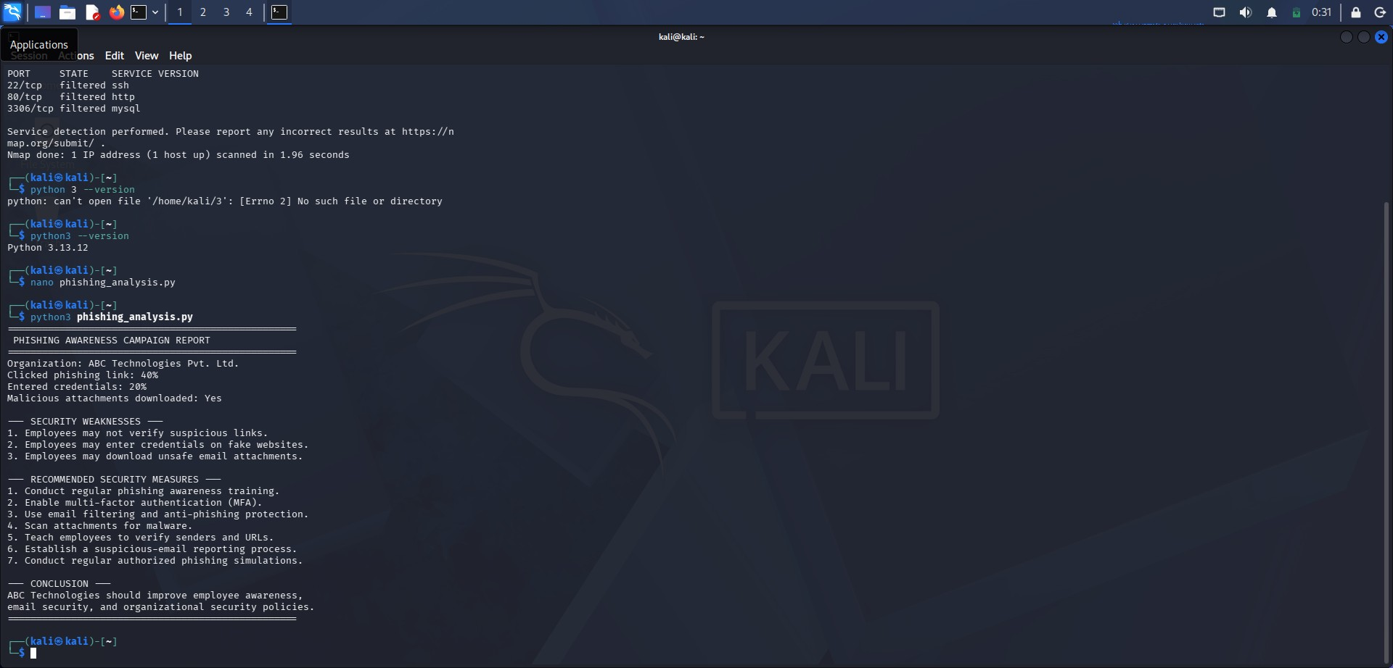
Figure 2: Phishing awareness campaign report generated by the analysis script

1. Report Analysis and Interpretation
The GoPhish campaign report for ABC Technologies Pvt. Ltd. shows that 40% of employees clicked the phishing link, 20% entered their login credentials on the fake page, and malicious attachments were downloaded. This means that a large share of staff failed the first test (recognising a suspicious link), half of those who clicked went further and handed over credentials, and the attachment download shows that malware delivery would also have succeeded. The result indicates a high susceptibility to social engineering, and every credential entered is a potential account takeover.

2. Security Weaknesses Demonstrated by the Employees
- Lack of link verification: Employees did not hover over or inspect URLs, sender addresses or domains before clicking (40% click rate).
- Credential disclosure on fake websites: 20% entered login details on a spoofed login page, showing that they cannot tell a genuine site from a cloned one, and that urgency and authority tricks work.
- Unsafe handling of attachments: Employees opened or downloaded unexpected attachments, which in a real attack could install ransomware, keyloggers or remote-access trojans.
- Low security culture: No habit of reporting suspicious emails, and weak awareness of urgency, fear and curiosity-based manipulation.
- Possible technical gaps: The phishing email reached user inboxes, so email filtering, attachment scanning and MFA may be missing or weak.

3. Recommended User Awareness Programs
- Regular security awareness training: Mandatory onboarding and periodic (e.g. quarterly) sessions covering phishing, spear phishing, vishing, smishing and social engineering tricks.
- Repeated phishing simulations: Run authorised GoPhish campaigns regularly, measure click and submission rates over time, and give instant "teachable moment" feedback to those who fail.
- Practical red-flag training: Teach employees to check the sender address, hover over links, look for spelling errors and urgent language, and never open unexpected attachments.
- Targeted training: Extra coaching for high-risk groups (finance, HR, executives, new joiners) and for repeat clickers.
- Reporting culture: Provide a "Report Phishing" button and reward quick reporting instead of punishing mistakes.

4. Recommended Email Security Controls
- Email filtering and anti-phishing gateway: Block known malicious domains and spam, and flag external emails with a warning banner.
- Multi-factor authentication (MFA): Makes stolen passwords insufficient on their own for logging in.
- Attachment scanning and sandboxing: Scan for malware and block risky file types such as executables and macro-enabled documents.
- Email authentication: Implement SPF, DKIM and DMARC to prevent domain spoofing.
- URL protection: Safe-link rewriting and web filtering to block access to known phishing sites; endpoint protection (EDR/antivirus) on all devices.

5. Recommended Organizational Policies
- Security and acceptable-use policy: Clear rules on email, attachments, passwords and reporting.
- Incident response procedure: A defined process to report, isolate affected machines and reset credentials immediately after a suspected phishing event.
- Strong password and access policy: Unique passwords, a password manager, least-privilege access and prompt removal of unused accounts.
- Verification policy: Sensitive requests (payments, credential resets) must be verified through a second channel.
- Regular audits: Periodic authorised social-engineering assessments with management review of the results.

Conclusion
ABC Technologies should reduce human risk through continuous awareness training and simulations, strengthen technical email defences with MFA, filtering and attachment scanning, and back both with clear organizational policies and a culture of reporting.
Question – 03
A DNS assessment report generated using the Dig tool shows that the organization's DNS server permits a successful DNS Zone Transfer (AXFR), exposing internal hostnames, mail servers, and DNS records. Analyze the report and explain the security implications of the exposed information. Discuss how attackers could exploit these findings and recommend best practices to secure the DNS infrastructure.

DNS Zone Transfer (AXFR) Assessment
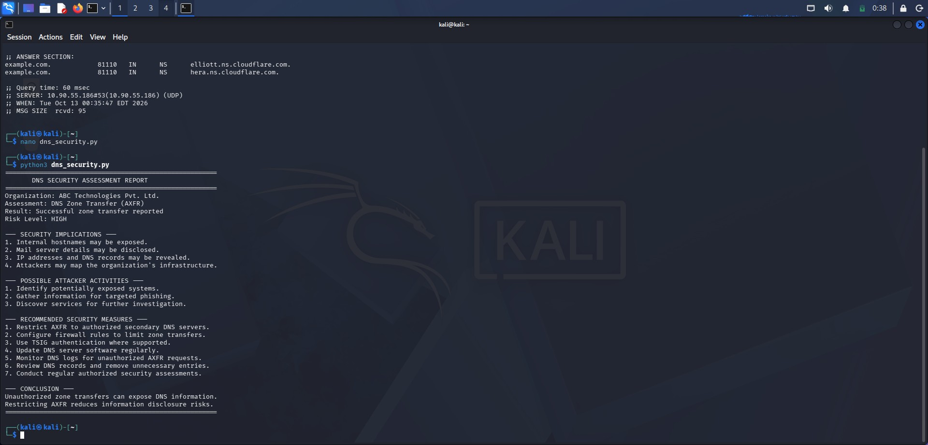
Figure 3: Dig output and DNS security assessment report showing a successful zone transfer

1. Report Analysis
The dig output queried the name server (SERVER: 10.90.55.186#53) for example.com, and the report generated for ABC Technologies Pvt. Ltd. states that a DNS zone transfer (AXFR) succeeded, with the risk level rated HIGH. A zone transfer is meant only for replication between a primary and its authorised secondary servers. If the server answers an AXFR request from any client, it hands over the entire zone file.

2. Security Implications of the Exposed Information
- Internal hostnames exposed: Names such as dev, test, vpn, admin or db reveal the internal naming scheme and valuable targets.
- Mail server details disclosed: MX records show the mail infrastructure, helping attackers plan phishing and spoofing.
- IP addresses and DNS records revealed: A, AAAA, CNAME, TXT and NS records disclose the IP space and services in use.
- Infrastructure mapping: Attackers obtain a complete map of the network without sending noisy scans.

3. How Attackers Could Exploit These Findings
- Reconnaissance: Identify live and potentially exposed systems, including forgotten development or staging servers that are weakly protected.
- Targeted attacks: Use the host list and mail records to craft targeted phishing and spoofing campaigns, and to choose specific servers for exploitation and brute-force attempts.
- Further investigation: Feed the discovered hosts into port scanning and vulnerability scanning, and use subdomain information for takeover attempts.

4. Best Practices to Secure the DNS Infrastructure
- Restrict AXFR: Allow zone transfers only to authorised secondary DNS servers (allow-transfer ACL by IP).
- Firewall rules: Limit TCP port 53 (used for zone transfers) to trusted servers.
- TSIG authentication: Use transaction signatures so only authenticated servers can request transfers.
- Patch and update: Keep the DNS server software up to date.
- Monitor and log: Watch DNS logs for unauthorised AXFR requests.
- Clean the zone: Review records and remove unnecessary entries; use split-horizon DNS to keep internal names off public servers; run regular authorised assessments.

Conclusion
An unrestricted zone transfer exposes the organization's DNS information and helps attackers map its network. Restricting AXFR to authorised servers, with TSIG, firewalling and monitoring, greatly reduces this information-disclosure risk.

